Revolutionizing your viewpoint: Google Glass

- Mahesh Mehandiratta, Bharati Vidyapeeth College of Engineering

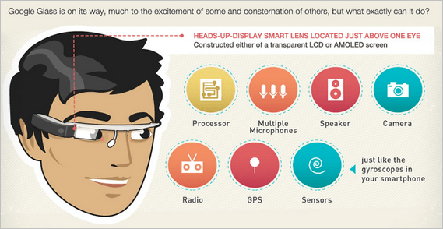

Just when we started to believe that we had the latest of tech in our pockets, Google is back again to prove us wrong. With the launch of the revolutionary google glasses, google has raised the bar for advanced technologies in the whole world. Though worn just like ordinary glasses, they provide a whole lot of extraordinary features that no one could ever imagine to be incorporated in a simple pair of spectacles. From a simple speaker to voice control, from 4g access to a multi functioning camera, from capability to send a simple text message to google maps and google translate. You name it, and google glasses have it. It feels no less than a whole smart phone right in front of your eye (yes, of course, in a much reduced size). The screen being just a tiny 0.5 inch display, uses prism technology to project the screen at our retina so that it appears to be a 25 inch screen placed at a distance of 2.4m. Amazing, isn't it? To utilize the power of this display, we have the augmented reality of google glasses. The glasses to enhance the overall user experience, display the collaboration of the real world image with a virtual image created by it, hence, assuring that you have the best of both worlds.

Though, otherwise completely voice controlled: with commands like "Ok glass”, "Ok glass, capture a pic", they also have a physical button and physical tap controls for functions like going to home screen, attending calls etc. You are always just a command away from clicking and recording HD photos and videos with its inbuilt camera. To add to it, google glasses also support ambient intelligence i.e. the device can adjust itself according to you and the environment around you so that you have the smoothest of experience with them. Currently, the glasses are already available to public for 1000$ in US and UK and have been a huge success for the grand brand google. But can their awesomeness enthrall the whole world? Well, that, only time will tell.